HOW TO REQUEST TIME OFF –VACATION OR SICK LEAVE
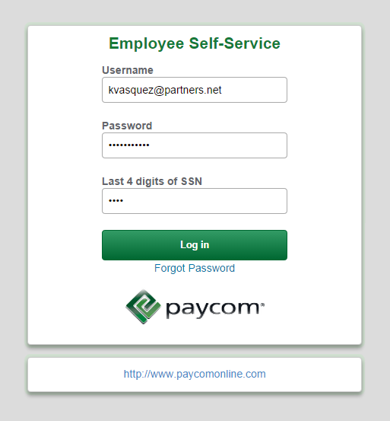
- Log into the Paycom Employee Self Service using your credentials.

- From the Employee Self Service home page, select the “Request Time Off” title.

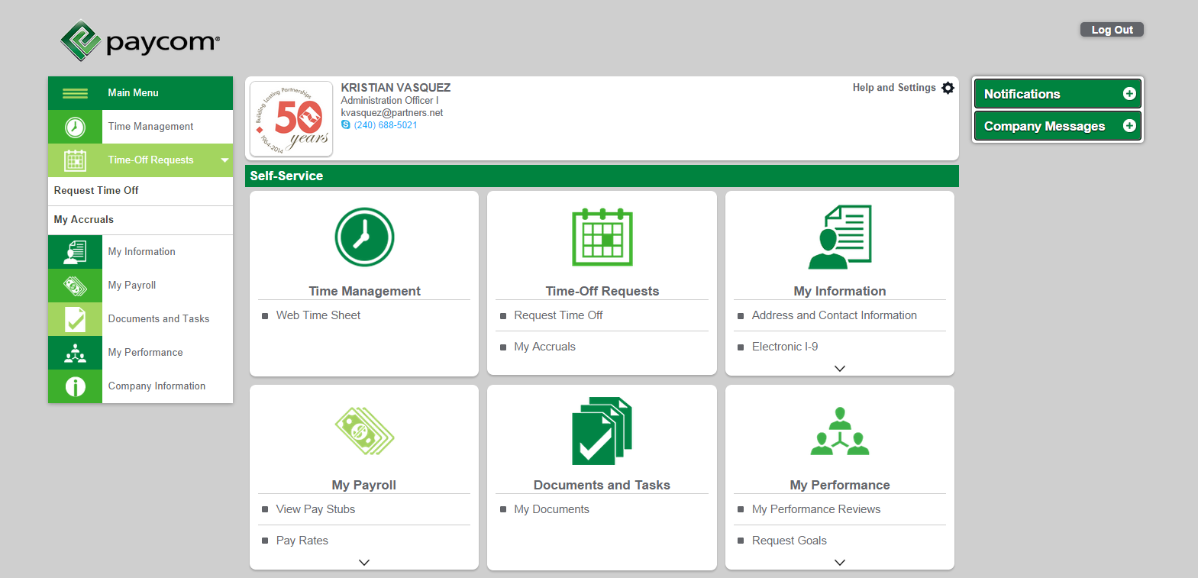

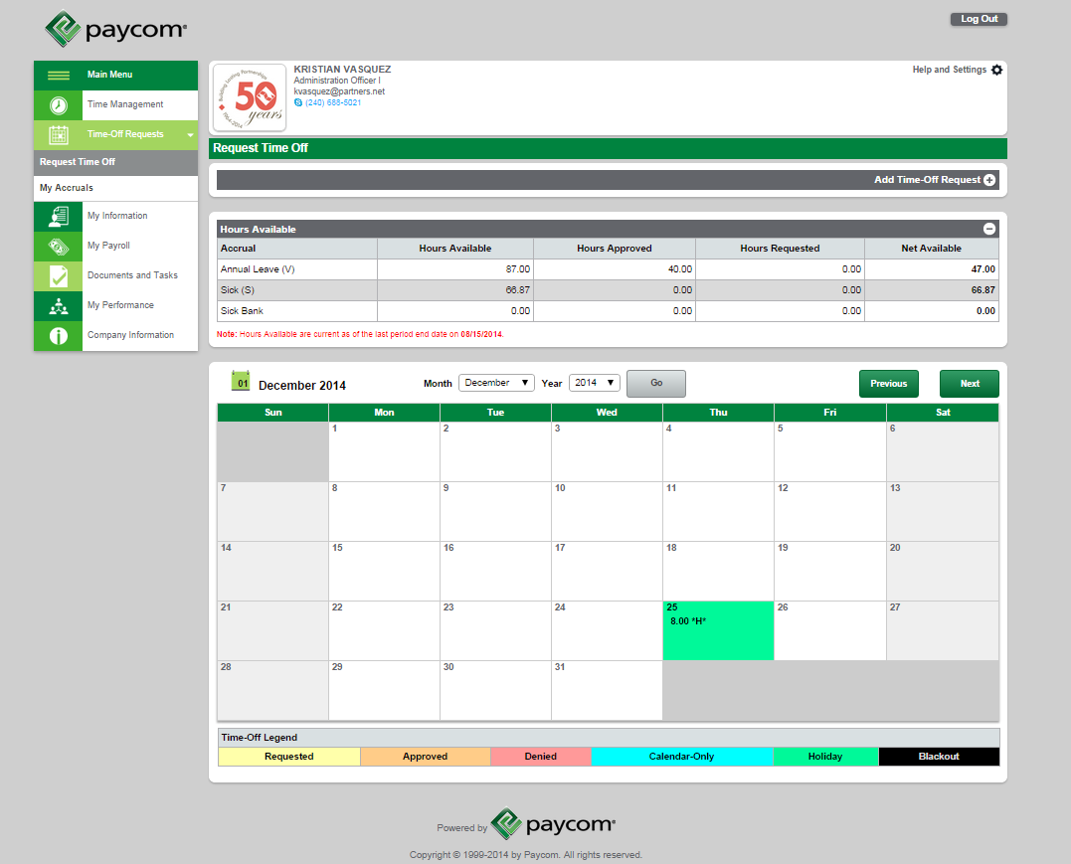
- Once the calendar opens, select the corresponding month for which you will be submitting your request for and click “Go”.
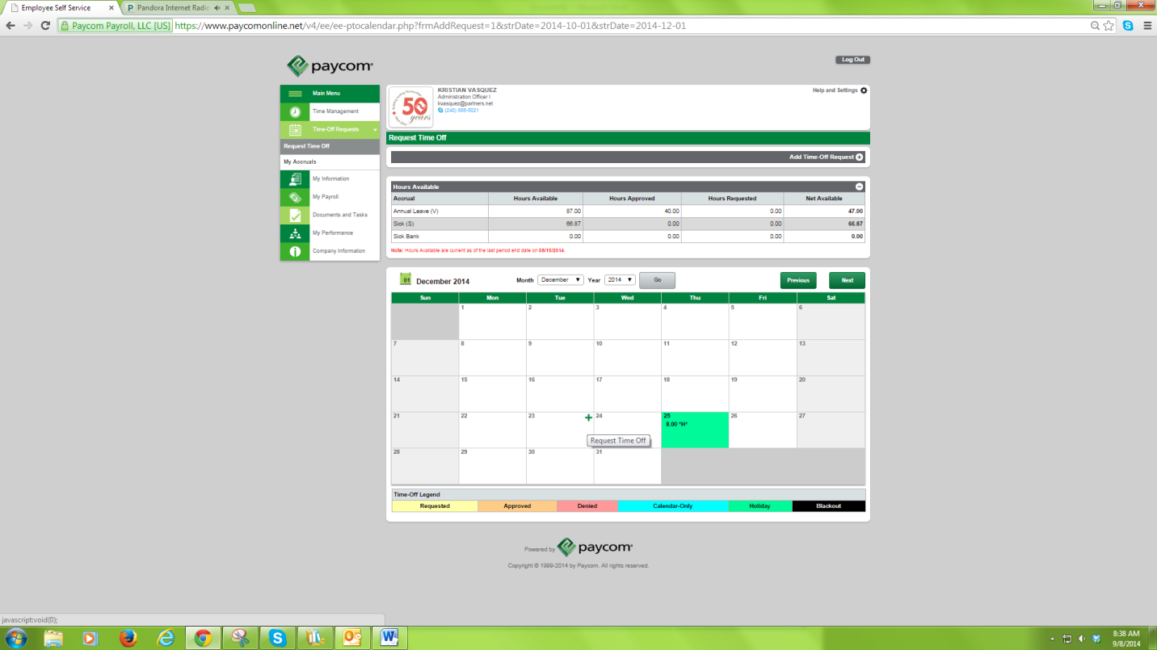
- Roll your mouse over the corresponding date, and a green “+” sign will appear on the upper right hand corner. Click on the green “+” sign and the time off window will open.
- In the Request Time Off window, make sure to fill in the following information:
- Hours per day (8)
- Type (Vacation or Sick)
- Day or Days (You may select a single day or a range of dates.)
- Ignore Weekends
- Don’t select Start Time
- Reason (Optional)

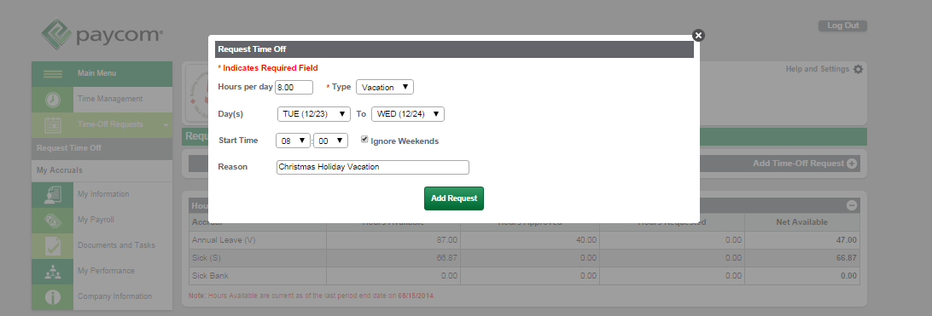
Finally click the green “Add Request” button.

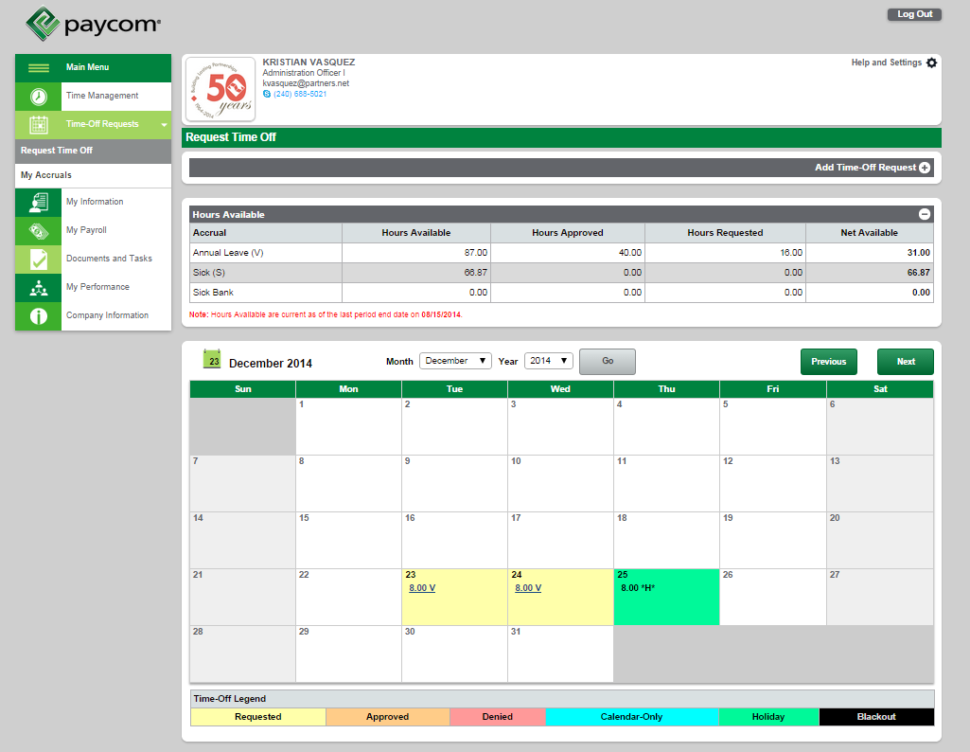
- Your page will reload and take you to your Request Time Off calendar homepage. You will see your requested dates highlighted in yellow. Once you’ve submitted a request an email will be sent to your supervisor. He/She will be required to approve or deny your request. Once they have either approved or denied your request an email confirmation will be sent to you.

